# ASSIGNMENT No. 3

**Problem Based Learning**

Course Title: Discrete Mathematics

Course Code: CSC-221

Class: BS (CS)-1 (A & B) Submission deadline: 25-12-2023

Course Instructor: Tooba Mehtab Marks: 10

***__________________________________________________***

***Instructions***

1. Students will perform this assignment in a group (maximum of 3 students).
2. Assignment should be done only on A4 size paper and will also be uploaded on LMS.
3. The deadline will not be extended for any reason.
4. Copied assignments would have zero marks.
5. Name, class, section, department, and enrollment number on the sheets must be mentioned correctly.
6. Make a single PDF file as both soft and hard copies are\ mandatory.

**Objective**

The purpose of this assignment is to apply what you learned about Discrete mathematics and its applications in algorithm designing, game theory and in artificial intelligence.

**Scenario**

Tic Tac Toe is a classic two-player game that is played on a 3x3 grid. You must design the same game on N x N grid. The objective of the game is to form a line of N of your symbols (either 'X' or 'O') horizontally, vertically, or diagonally on the grid. The game is turn-based, and players take alternate turns to make their moves.

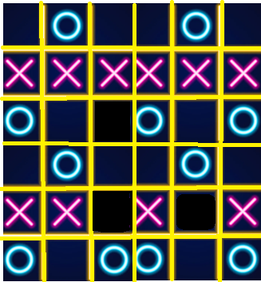

Game Setup:

* The game begins with an empty N x N grid.
* Two players are involved, one using 'X' and the other using 'O'.
* Players decide who goes first, usually through a coin toss or another random method.

Gameplay:

* Players take turns to make a move.
* Each move consists of placing their symbol ('X' or 'O') in an empty cell on the grid.
* The goal is to strategically place symbols to create a line of three vertically, horizontally, or diagonally.

Winning:

* The game ends when one of the players successfully forms a line of three of their symbols in a row.
* The first player to achieve this is declared the winner.

Draw:

* If the entire grid is filled, and no player has formed a winning line, the game is a draw.

**Deliverables**.

1. Use propositions, logical connectives, and rule of inference to **translate** logical rules for the Tic Tac Toe game. such as "If a player wins, then the game is over," or "If the board is full and there is no winner, then the game is a draw." Ensure that your rules are clear, concise, and logically sound. **[CLO 2, PLO 2, C2]**
2. **Relate** the counting techniques to find the following, consider three different values for N (for example N = 3, 4 and 6) **[CLO 2, PLO 2, C2]**
   1. The number of ways a player can achieve victory (winning combinations),
   2. Determine all possible ways players can marked the tic tac toe.
   3. Draw a tree diagram for all possible moves, consider the grid length N = 3
   4. Which are the best moves leads towards the winning position, analyze by the tree diagram of part iii.
3. **Develop** pseudo code to identify .**[CLO 4, PLO 4, C3]**
   1. all winning position of the game.
   2. to select the best move.
   3. for alternative turns of the players.
   4. that the game is draw now.

**Note**: Above mentioned deliverables must be provided in one file with a title and table of content in soft and hard copies both.

**Evaluation Criteria**

|  |  |  |
| --- | --- | --- |
| **1.** | **Translate** logical rules for the Tic Tac Toe game | **25%** |
| **2.** | **Relate** the counting techniques | **25%** |
| **3.** | **Develop** pseudo code | **25%** |
| **4.** | Report and Viva | **25%** |